**Software Requirements Specification**

**for**

**Software Engineering - CS4398**

**Version 1.0**

**Prepared by Derek Sittenauer, Andres Sosa, Osamuyi Edomwande, Conor Schindel**

**02/13/2018**

**Table of Contents**

**Table of Contents ii**

**1. Introduction 3**

1.1 Purpose

1.2 Problem Statement

**2. Statement of Functional Requirements 3-7**

2.1 Product Functions

2.2 Post Feed

2.3 Posting

2.4 Commenting

2.5 Upvoting/Downvoting

2.6 User Classes and Characteristics

2.7 Operating Environment

**3. Nonfunctional Requirements 8**

3.1 Performance Requirements

3.2 Safety Requirements

3.3 Security Requirements

3.4 Reliability Requirements

**4. Design and Implementation Constraints 9**

# Introduction

## Purpose

The purpose of this document is to give a detailed description of the requirements for the “The Goat” software. It will illustrate the purpose and complete declaration for the development of system. It will also explain system constraints, interface and interactions with other external applications. This document is primarily intended to be proposed to a customer for its approval and a reference for developing the first version of the system for the development team

## Problem Statement

Teenagers and people everywhere are lacking an anonymous platform to communicate and express ideas and opinions without worrying about people knowing who’s behind the message. By using our app, we would offer users a way to communicate anonymously with people within their area via an online forum to help get things off their chest. It’s perfect for teenagers and young adults alike.

# Statement of Functional Requirements

## Product Functions

This app will start with a basic online forum platform, where users are able to create text posts and share them with people in their area. Other users on the app will be able to like and add comments on posts.

## Post Feed

* + 1. Description and Priority

The post feed will show all of the posts that fall under certain criteria specified by the user before loading. It will also have a refresh feature to update the feed and get new posts. This is the applications main function and the highest priority.

* + 1. Stimulus/Response Sequences

Upon loading the application the post feed will be updated and displayed. A refresh button will allow the user to check for new posts and update the feed when pressed.

* + 1. Functional Requirements

REQ-1: The application will need to be able to pull the feed data from a server containing the post data.

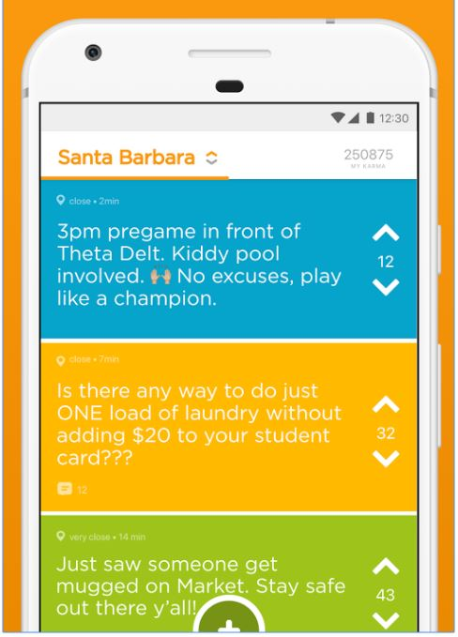REQ-2: The application will need to be able to requery the server for more data when the users requests and update for their feed.

## Posting

Users will be able to create posts to add to the feed, which other users would be able to comment on and interact with.

REQ-1: User will submit post which the data gets sent to the database.

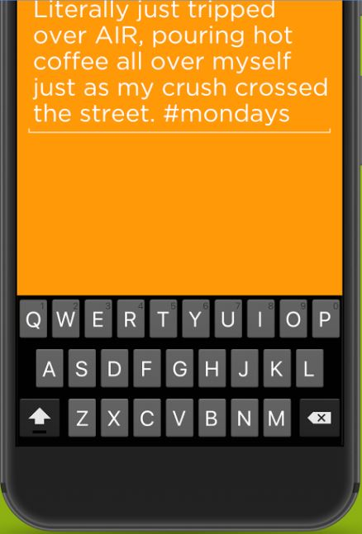REQ-2: Database sends post data out to other users’ phones so they are able to view the post locally

## Commenting

Commenting will allow the user to leave comments on posts as they please, under the guise of anonymity. This is the applications second most important function, so it is high priority.

From the screen for viewing a post, the user will be provided an interface to type and post their comments. Posting a comment sends it to the server so that it may be viewed by others. A refresh option will also allow a user to show any new comments on a post.

REQ-1: The application will need to be able to upload comment data to the server so that other users can read all of the comments on a post.

REQ-2: The application will need to be able to re-query the server for updated data when users refresh the comments on a post.

**2.5 Upvoting/Downvoting**

2.4.1

User will have the option to either upvote or downvote a post.

Upvotes and downvotes will be tallied separately. The posts with the most likes will be featured in a “Trending” tab.

2.4.2

Users will be provided with two icons for every post/comment, and press

these to select their vote. After voting, the application will update to reflect the post or comments new vote count.

2.4.3

Users will also have the ability to downvote a post which will go against a

vote count. A post with 4 downvotes will be taken off the forum.

## 2.6 User Classes and Characteristics

Since the market for this application is limited to a highly specific subset of users, there is only one user class for this application. These users are all younger people with an adequate amount of technical expertise having grown up with technology, likely at similar stages in their education as well. There is no need to differentiate beyond that because the application will not have a learning curve requiring different user classes for users with different experience or frequency of use.

## 2.7 Operating Environment

This application will operate on any phone running an android operating system, as long as it’s updated.

# Other Nonfunctional Requirements

## Performance Requirements

In order to ensure a smooth user experience, the communication between the application and the database will need to be fairly quick. It should take no longer than .5 seconds for the application to open, complete, and close communication with the database, although user experience may vary depending on their own internet connection. As for the application itself, response times should be limited to .1 second or below so that the app feels responsive.

## Safety Requirements

Safeguards implemented in the app will be a word checker that can detect “hurtful” words. When these words are detected the post will fail to be added to the forum. Furthermore if a user gets reported over three times they’ll be eligible to post on the app for a certain time period. By implementing these requirements, it prevents users from cyberbullying, posting threats, and create a fun and friendly environment for all users of the app.

## Security Requirements

Since the platform is anonymous, security is a principle concern for development. Users will have secure connections from the application’s client to the database so that their privacy is protected, and their posts cannot be attached to an identity.

**3.4 Reliability Requirements**

Outside of fringe-case hotfix situations and short term scheduled maintenance for application updates, the application will have one hundred percent uptime.

# 4. Design and Implementation Constraints

Our app will be restricted to Android devices only. This will include both android phones and tablets alike. Due to technical restrictions, we will not be able to port a version of the app over to iOSX systems because we do not have ease of access to iOSX machines. This is due to restriction of technology we have to work with. Time is another restriction to take into account while working on this project since we only have a semester to complete it as well as dealing with additional course loads. It may be difficult to learn all the technologies to fully decorate our app with all the features and visual aesthetics we envisioned.